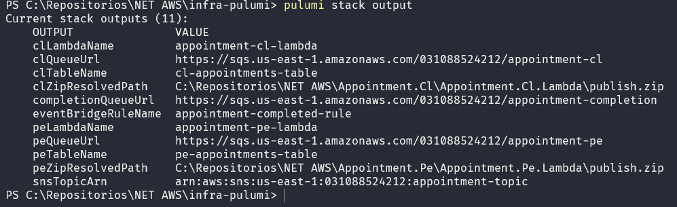
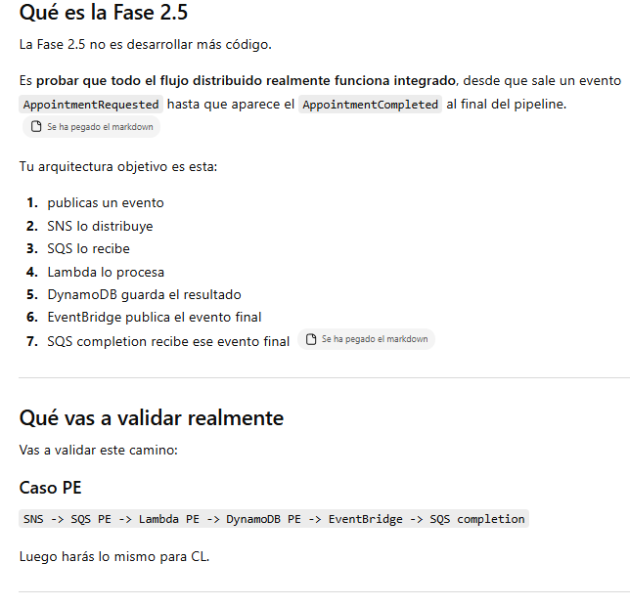

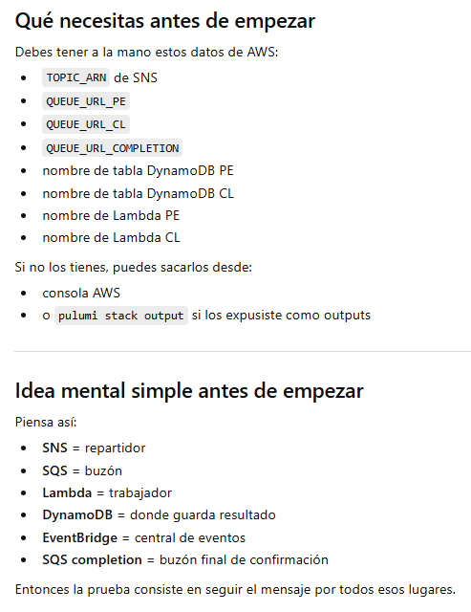

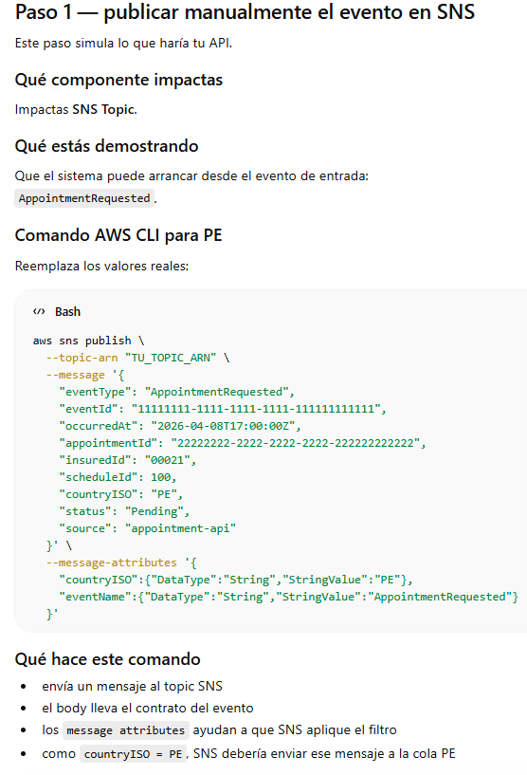

aws sns publish `
--topic-arn "TU_TOPIC_ARN" `
--message '{
"eventType": "AppointmentRequested",
"eventId": "11111111-1111-1111-1111-111111111111",
"occurredAt": "2026-04-08T17:00:00Z",
"appointmentId": "22222222-2222-2222-2222-222222222222",
"insuredId": "00021",
"scheduleId": 100,
"countryISO": "PE",
"status": "Pending",
"source": "appointment-api"
}' `
--message-attributes '{
"countryISO":{"DataType":"String","StringValue":"PE"},
"eventName":{"DataType":"String","StringValue":"AppointmentRequested"}
}'

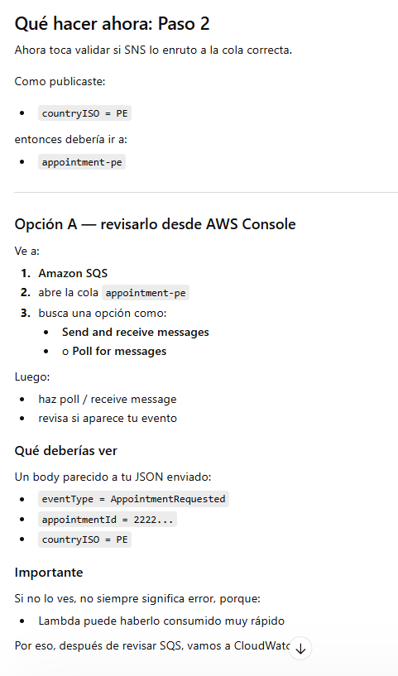

TAMBIEN EL PASO 02 LO PUEDES VALIDAR POR CONSOLA, PERO EL MENSAJE POSIBLEMENTE NO SE VERA PORQUE SE PROCESA DEMASIADO RAPIDO:
